**EXP 8 : CREATE AN ARIMA MODEL FOR TIME SERIES FORECASTING**

**AIM:**

To implement programs to create an ARIMA model for time series forecasting.

**PROCEDURE:**

**1.Import necessary libraries**

import pandas as pd

import matplotlib.pyplot as plt

from statsmodels.tsa.arima.model import ARIMA

**2. Load the dataset**

file_path = '/content/PRICE_AND_DEMAND_201801_NSW1.csv'

df = pd.read_csv(file_path)

**3. Check columns and first rows**

print(df.columns)

print(df.head())

**4. Convert datetime column**

df['SETTLEMENTDATE'] = pd.to_datetime(df['SETTLEMENTDATE'])

**5. Set datetime as index**

df.set_index('SETTLEMENTDATE', inplace=True)

**6. Keep only numeric columns**

df_numeric = df[['TOTALDEMAND']].copy()

**7. Resample to hourly average**

df_hourly = df_numeric.resample('H').mean()

df_hourly.dropna(inplace=True)

**8.Plot the time series**

plt.figure(figsize=(12, 6))

plt.plot(df_hourly.index, df_hourly['TOTALDEMAND'], label='Total Demand')

plt.title('Hourly Total Demand')

plt.xlabel('Time')

plt.ylabel('Demand')

plt.legend()

plt.tight_layout()

plt.show()

**9. Fit ARIMA model**

model = ARIMA(df_hourly['TOTALDEMAND'], order=(5, 1, 0))

model_fit = model.fit()

model = ARIMA(df_hourly['TOTALDEMAND'], order=(5, 1, 0))

forecast = model_fit.forecast(steps=24)

**10. Plot forecast**

plt.figure(figsize=(12, 6))

plt.plot(df_hourly.index[-48:], df_hourly['TOTALDEMAND'][-48:], label='Historical')

plt.plot(pd.date_range(df_hourly.index[-1], periods=25, freq='H')[1:], forecast, color='red', label='Forecast')

plt.title('Total Demand Forecast (Next 24 Hours)')

plt.xlabel('Time')

plt.ylabel('Demand')

plt.legend()

plt.tight_layout()

plt.show()

**OUTPUT:**

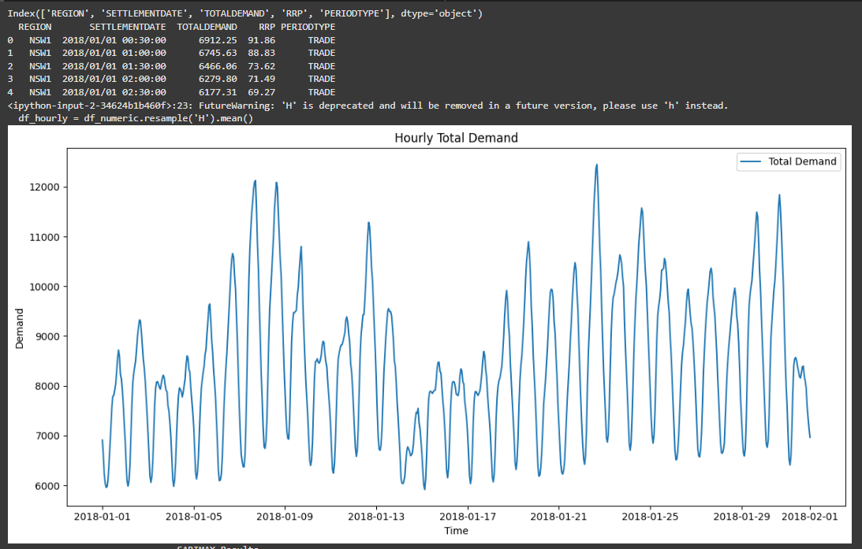

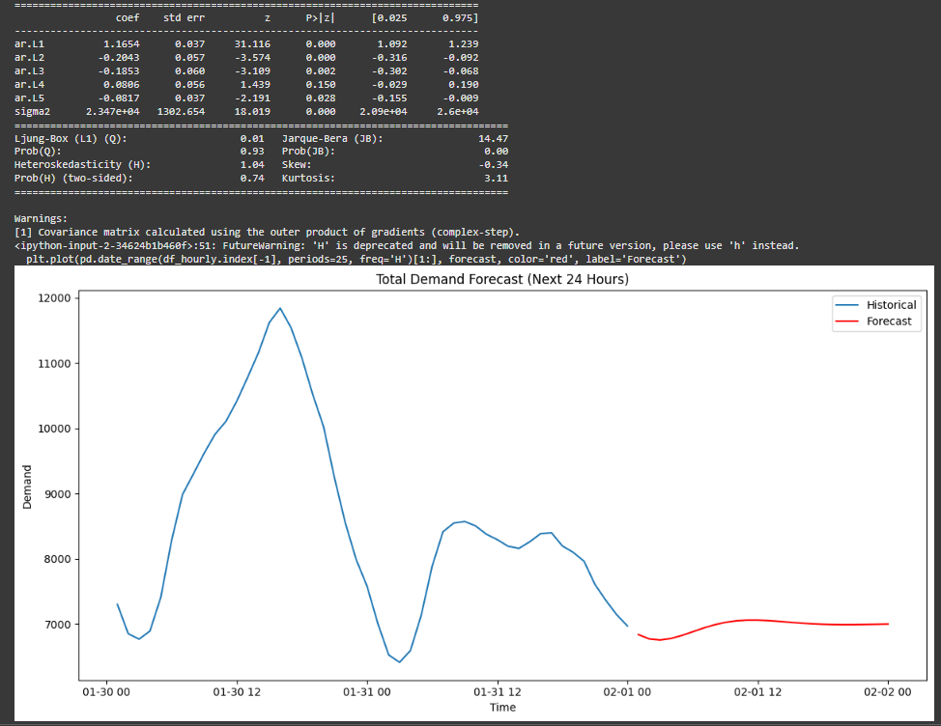

**RESULT:**

Thus the program for creating an ARIMA model for time series forecasting has been implemented and verified successfully.